<https://forums.raspberrypi.com/viewtopic.php?t=25100#:~:text=Re%3A%20Heat%20Dissipation%20and%20Cooling%20for%20the%20Pi&text=Ultimately%20the%20Pi%20does%20not,if%20memory%20serves%20me%20correctly>.

<https://copperhilltech.com/content/The%20Operating%20Temperature%20For%20A%20Raspberry%20Pi%20%E2%80%93%20Technologist%20Tips.pdf>

<https://www.pololu.com/product/1480#:~:text=The%20sensor%20can%20measure%20concentrations,more%20information%20about%20the%20sensor>.

<https://www.pololu.com/file/0J309/MQ2.pdf>

<https://quartzcomponents.com/products/mq-2-gas-sensor-module#:~:text=MQ2%20Gas%20sensor%20module%20works,of%20200%20to%2010000%20ppm>.

<https://www.physicsforums.com/threads/why-does-increasing-the-cross-sectional-area-of-a-wire-reduce-heat-dissipation.803887/#:~:text=The%20main%20factors%20that%20affect,area%20for%20heat%20to%20dissipate>.

Overview

This flammable gas and smoke sensor detects the concentrations of combustible gas in the air and ouputs its reading as an analog voltage. The sensor can measure concentrations of flammable gas of 300 to 10,000 ppm.The sensor can operate at temperatures from -20 to 50°C and consumes less than 150 mA at 5 V. Please read the MQ2 datasheet (184k pdf) for more information about the sensor.

In general, Raspberry Pi’s tend to run 20-30°C above the ambient temperature of the room they are in. If you are pushing your Raspberry Pi to the max and using the full CPU/GPU, then you might run into a situation where the Pi will start to slow itself down to prevent any damage

Another interesting fact about the operating temperature was the bottom of the range. While Raspberry Pi has qualified the board down to 0°C, there is a rumor that the pi can operate while submerged in liquid nitrogen. I was unable to find the exact source of this rumor but it wouldn’t surprise me if it were true.

Ultimately the Pi does not need any heat sinks or cooling for that matter. The chip is rated to go as high as 85c if memory serves me correctly. Cooling when the temp is caused by external factors is achieved by first trying to control the external source (Not always possible) you could go with a case that has no top and placing a fan nearby this does not have to be attached to the Pi at all a room fan can work. But if the external temp is just as hot as the chip no cooling will occur.

**MQ2 Gas sensor module** works on 5V DC and uses around 800mW. It can detect LPG, Smoke, Alcohol, Propane, Hydrogen, Methane and Carbon Monoxide concentrations in a range of 200 to 10000 ppm.

The main factors that affect heat dissipation in wires include the material of the wire, its diameter, and the surrounding environment. Different materials have varying levels of conductivity and resistance, while a larger diameter allows for more surface area for heat to dissipate. The ambient temperature and air flow around the wires also play a role in heat dissipation

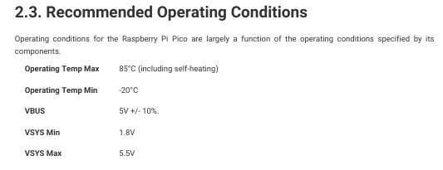

A snip from the raspberry pi documentation